**1. Aim:** Define a **class** Shape whose attributes are radius, length and width calculate the perimeter of the rectangle and circle. Use **constructors and destructors**.

**Software Used:**

* **IDE:** Visual Studio Code
* **Terminal:** Windows Terminal
* **Shell:** zsh
* **Compiler:** gcc

**Program:**

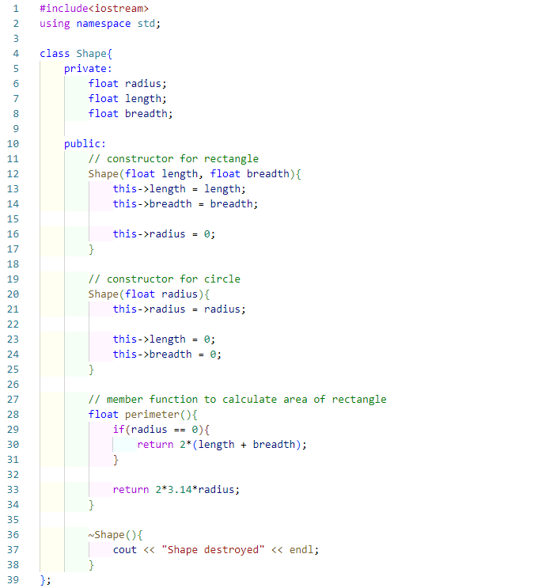

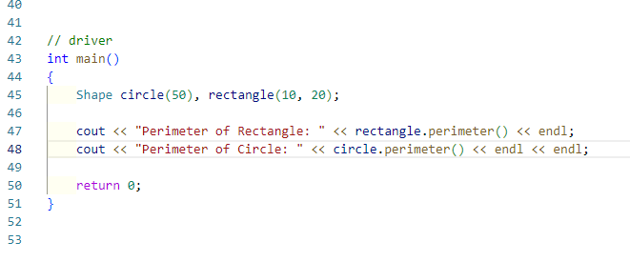

**Output:**

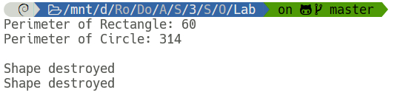

**2. Aim:** Create a class Person which includes: character array name of size 64, age in numeric, character array address of size 64, and total salary in real numbers (divide salary in different components, if required). Make an **array of objects** of class Person of size 10.

* 1. Write **inline** function that obtains the youngest and eldest age of a person from a class person using arrays.
  2. Write a program to develop the salary slip and display result by using constructors.

**Software Used:**

* **IDE:** Visual Studio Code
* **Terminal:** Windows Terminal
* **Shell:** zsh
* **Compiler:** gcc

**Program:**

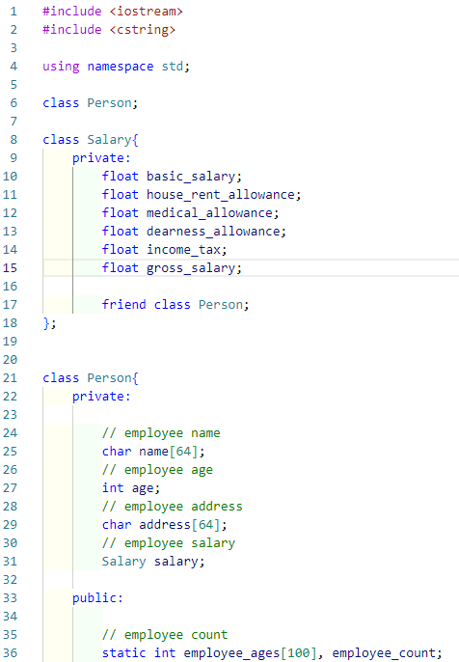

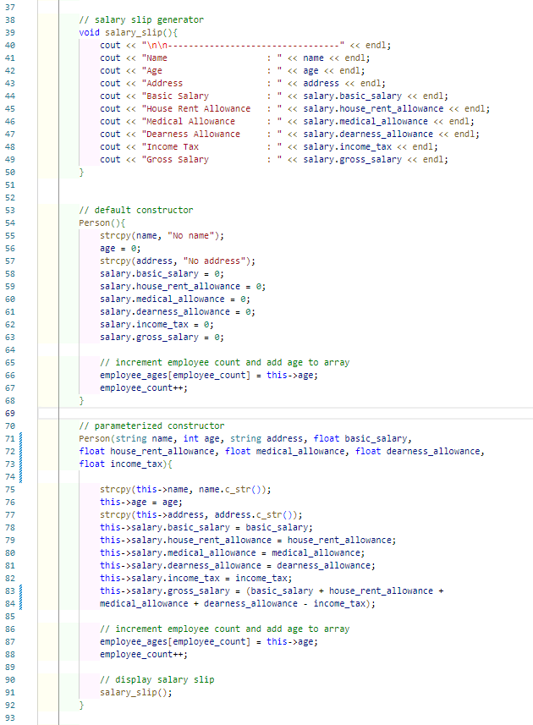

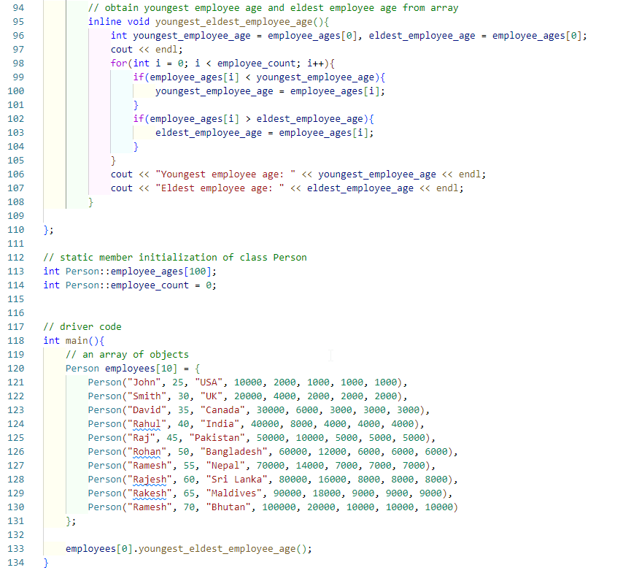

**Output:**

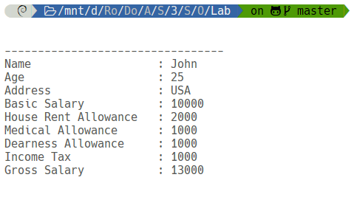

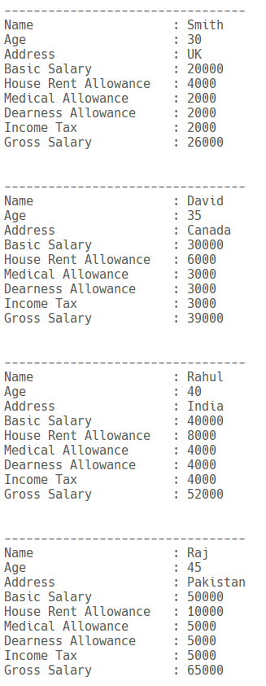

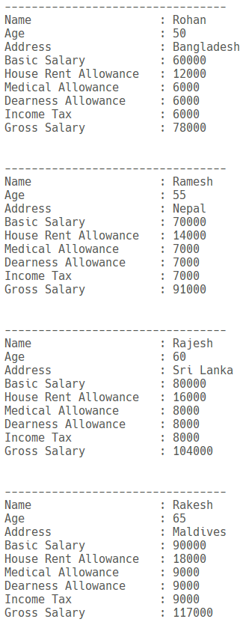

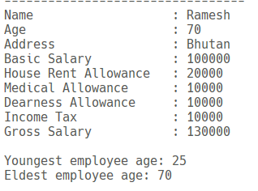

**3. Aim:** Write a program to find the area (function name AREA) of circle, rectangle and triangle by **Function overloading** concept.

**Software Used:**

* **IDE:** Visual Studio Code
* **Terminal:** Windows Terminal
* **Shell:** zsh
* **Compiler:** gcc

**Program:**

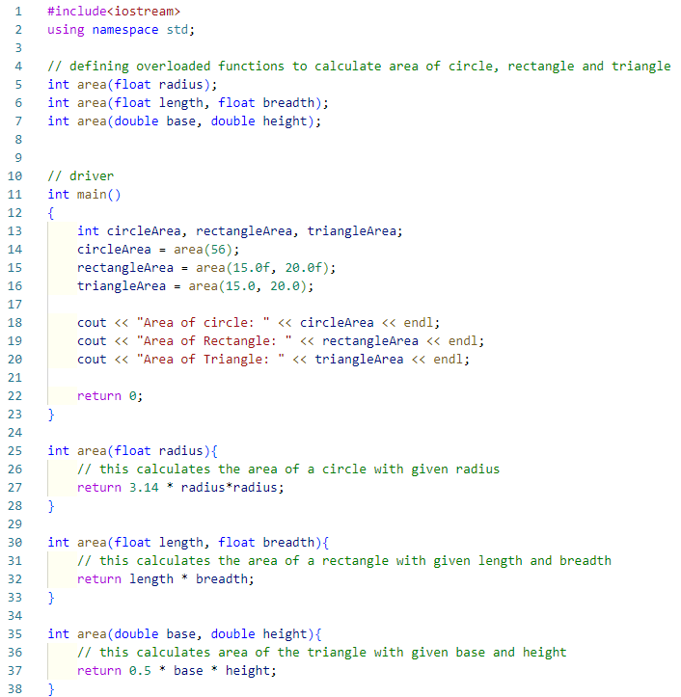

**Output:**

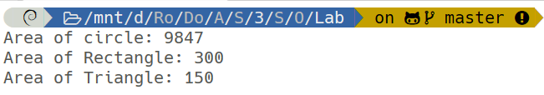

**4.1 Aim:** Write a program to swap two numbers (create two classes) by using **Friend function.**

**Software Used:**

* **IDE:** Visual Studio Code
* **Terminal:** Windows Terminal
* **Shell:** zsh
* **Compiler:** gcc

**Program:**

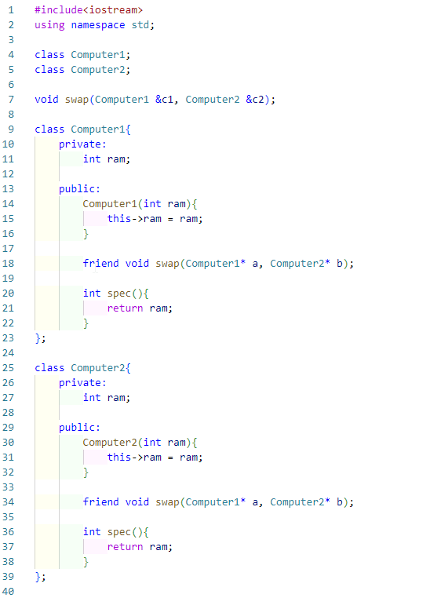

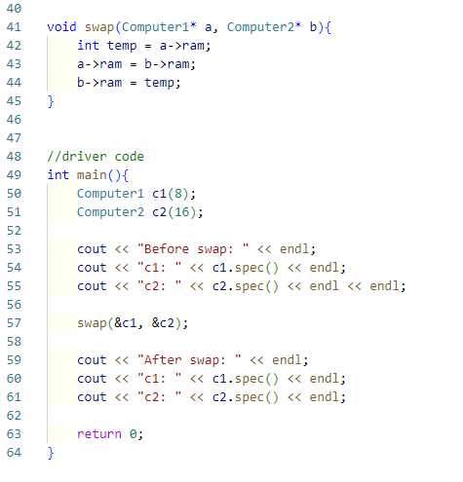

**Output:**

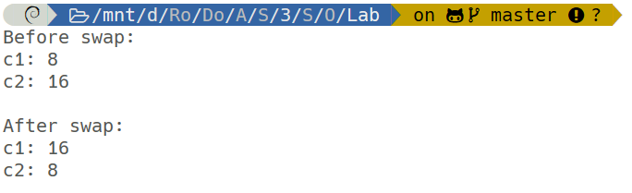

**4.2 Aim:** Write a program to create two classes DistM and DistF which store the values of distance. DistM stores distance in meters and centimetres and DistF stores distances in feet and inches. Read values for the class object and add one object of DistM with another object of DistF. Use a **friend function** for the addition operation and display answer in meter and centimetres.

**Software Used:**

* **IDE:** Visual Studio Code
* **Terminal:** Windows Terminal
* **Shell:** zsh
* **Compiler:** gcc

**Program:**

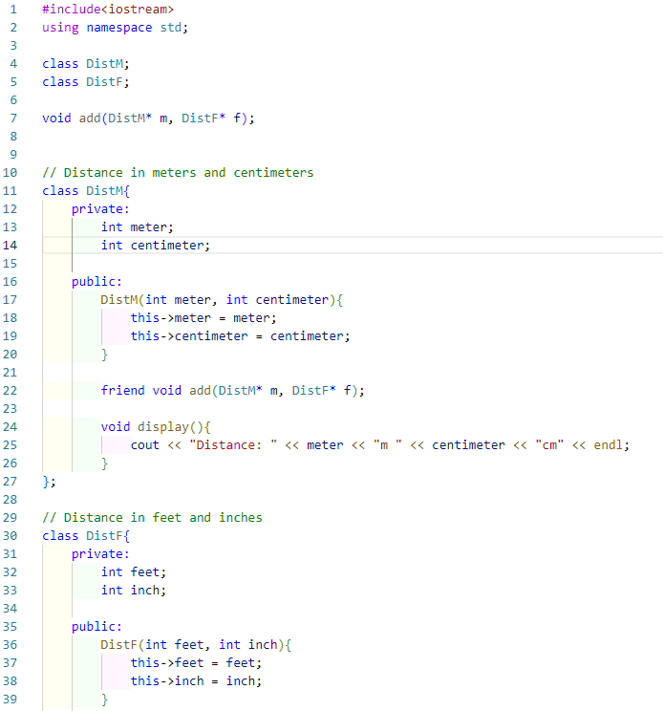

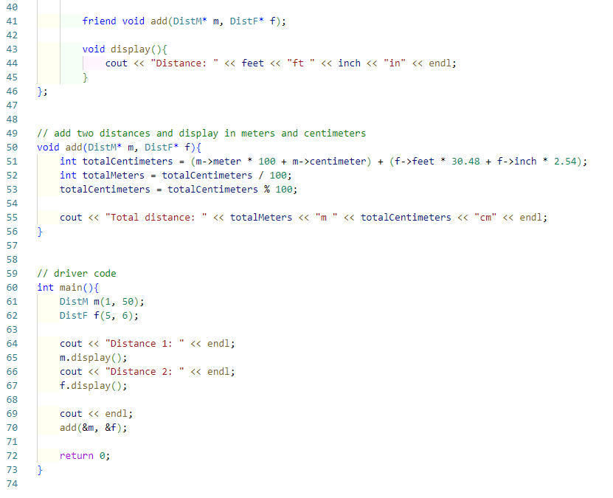

**Output:**

